**Name – Mujeeb ur Rahman Khan**

**Batch - B**

**Roll No - 37036**

**Class - TE IT B**

**Assignment No.2**

**Title :**

A] Create version control account on GitHub and using Git commands to create repository and push your code to GitHub.

**Code :**

1. **git init**

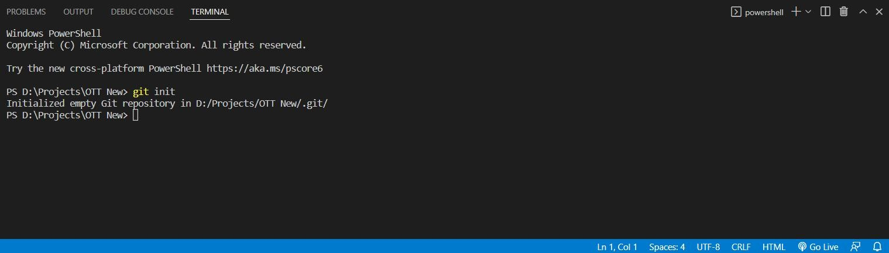

1. g**it add .**

**git commit -m “First Commit”**

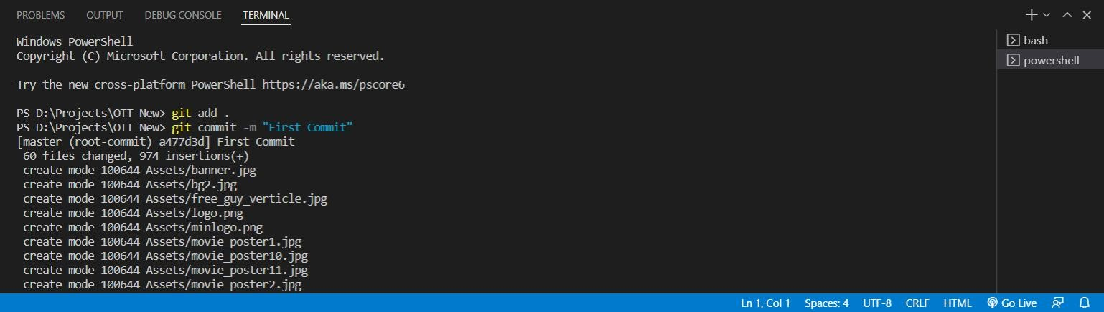

1. **git remote add origin** https://github.com/khan-mujeeb/Compose-Calculator

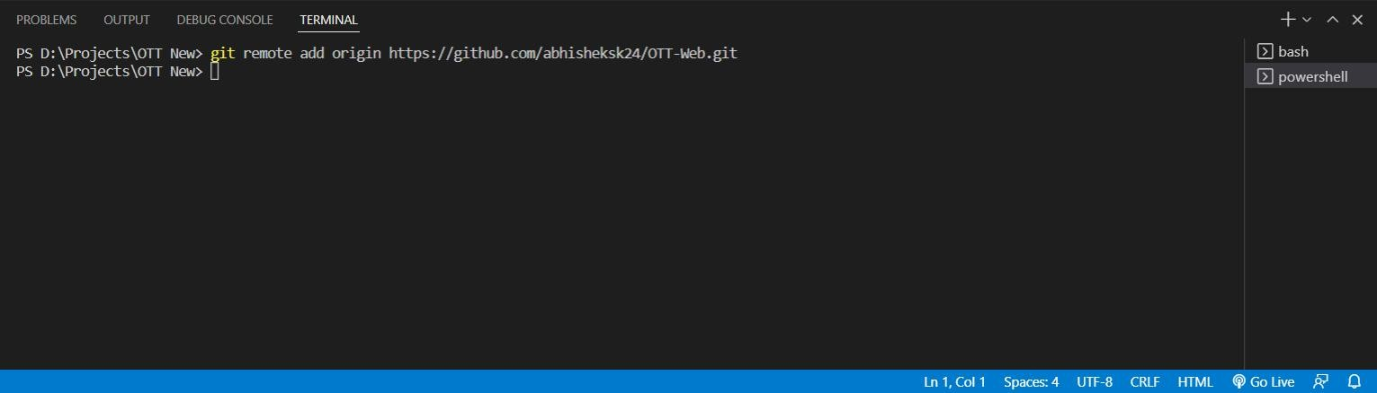

1. **git push --set-upstream origin master**

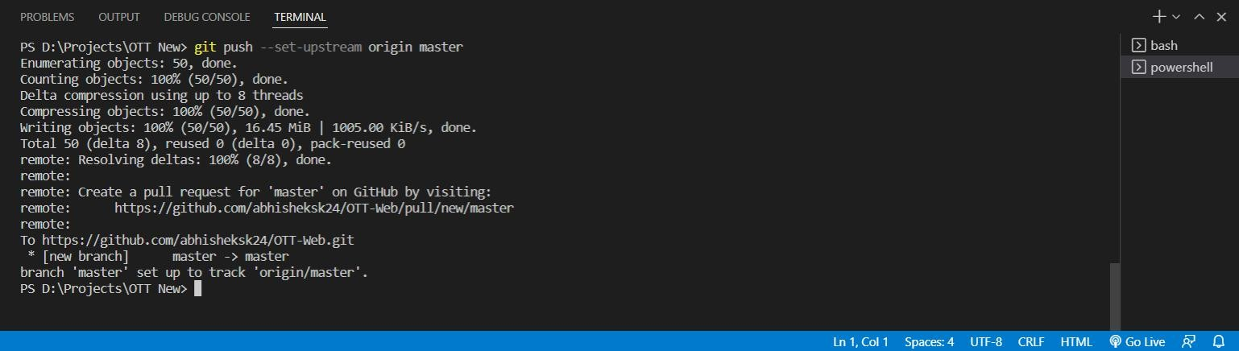

1. **git pull origin master**

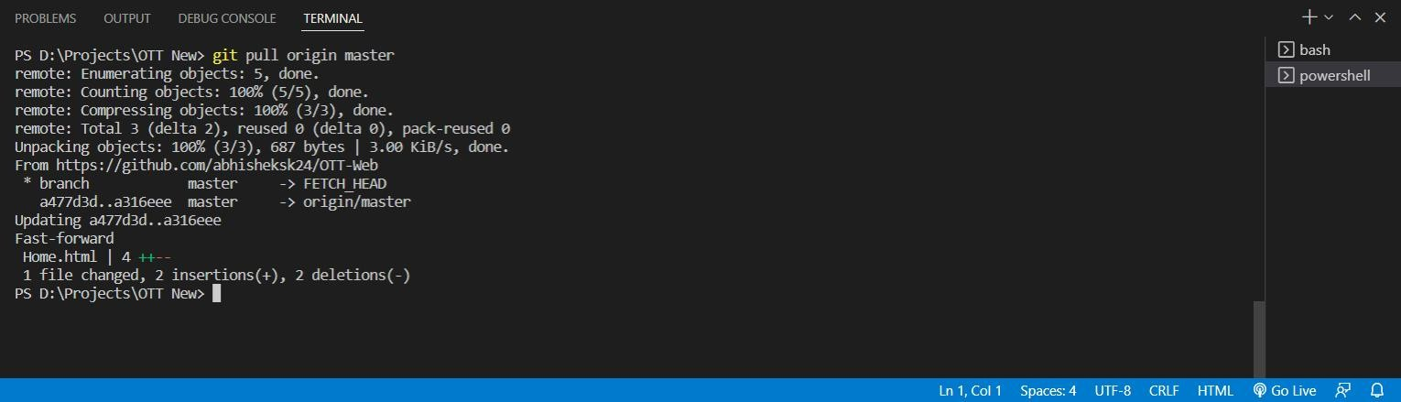

1. **Updated GitHub repository**

